BC2402: Designing and Developing Databases

Week 5 Class Exercises – Advanced SQL

Objectives
For additional practice with SQL, figure out the following queries using the hospital database (hospital.sql) in MySQL.

Instructions
- These lab exercises are best executed by first planning you SQL statements before executing it in the database.

- For each exercise, the output of the query is provided for a better understanding of what is required.

- Required: The SQL statement that would produce the result presented for each exercise. Answers are provided later separately. It is highly recommended that you try the exercises without referring to the answers. Refer to the answers as the last resort and to check on your syntax.

- The ER Diagram is as follows:

The red portion of the ERD is not included in this exercise.

- The relational schema is as follows:
Doctor [StaffNo, Position, Specialty]
Nurse [StaffNo, SupNo, Ward]
Patient [PatientID, PatientName, DoctorNo, WardNo]
Staff [StaffNo, StaffName]
Ward [WardNo, WardName, MaxBeds]

Advanced SQL Exercises

- What are the names and staff IDs of the doctors who are “Associate doctor”?

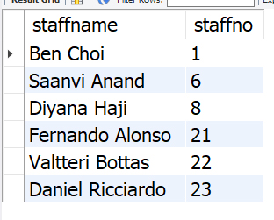

- Which patients (in alphabetical order) are treated by doctor Saanvi Anand?

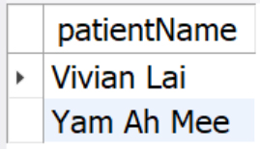

- How many patients are in each ward?

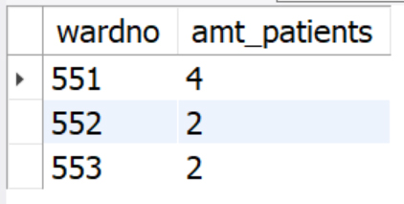

- Which wards have more than 1/3rd of their beds occupied? Note: For this to work, maxbeds must be part of the groupby.

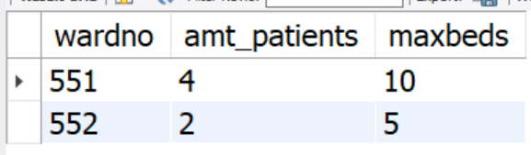

- Which wards have two patients with the same name? What are the IDs and names of the patients?

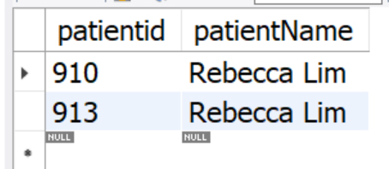

- What are the names of the nurse supervisors (i.e., which nurses have no supervisors?)? Order your results alphabetically.

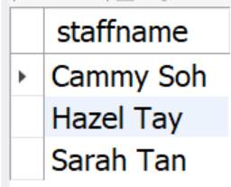

- Give the names of the nurses that Cammy Soh supervises.

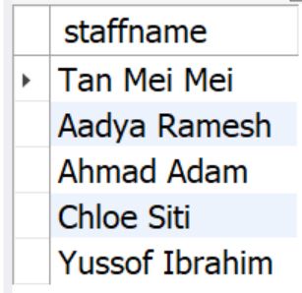

- Find me the doctors that are not treating any patients.

